Dataverse Toolbelt

User Guide

Contents

App Overview 2

Dataverse Instance Connections 2

Creating a new connection 2

Create a Connection using the SDK Tooling Connector 2

Create a connection saved and encrypted by the app 4

Manage Saved Connections 6

App Features 7

Query & Update Data 7

Customisation Import 9

Migrate Records 13

Solution Transfer 14

Text Field Search 16

Configure Autonumber 18

Customisation Export 19

Excel Import 20

Instance Comparison 22

Record Counts 23

# App Overview

The Dataverse Toolbelt is a Windows Desktop app which has been created to improve productivity building and administering apps built on the Microsoft Dataverse and Dynamics for CE platform

The app has a range of features includes querying data. bulk operations, data import and migration, importing table and field customisations from Excel, and solution deployment. Using saved connections these features enable users to achieve outcomes in a fraction of the time it takes using other tools or the native web application

# Dataverse Instance Connections

The Dataverse Toolbelt allows multiple instance connections to be saved in the app. Once created these connections can be made ‘active’ by clicking the connection button at the top right of the app

Some features such as Query & Update data will load for the current active connection, whereas other like the Solution Transfer feature do not act on the active connection, but require you to explicitly select each connection as you progress through the dialog

## Creating a new connection

To create a new connection to a Dataverse instance click the connection button at the top right of the app then select Create New in the dropdown menu

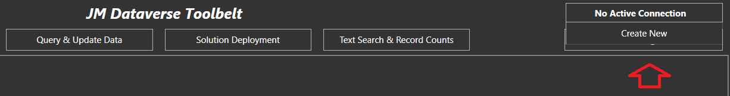

When creating a connection there are 2 options

1. Create a connection using the Microsoft SDK Tooling Connector
2. Create a connection saved and encrypted by the app

Option 1 has the advantage of MFA support, and saves connections in your windows user accounts credentials managers  
<https://support.microsoft.com/en-us/windows/accessing-credential-manager-1b5c916a-6a16-889f-8581-fc16e8165ac0?WT.mc_id=DX-MVP-5004940#create-a-non-interactive-user-account>

Option 2 is generally simpler to connect, but does not support MFA. It saves connection in a different form by storing them in the apps settings folder on disk encrypted with .NET libraries securely for the current user

## Create a Connection using the SDK Tooling Connector

To connect using the SDK connector click the button labelled Use XRM Tooling Connector in the connection entry form

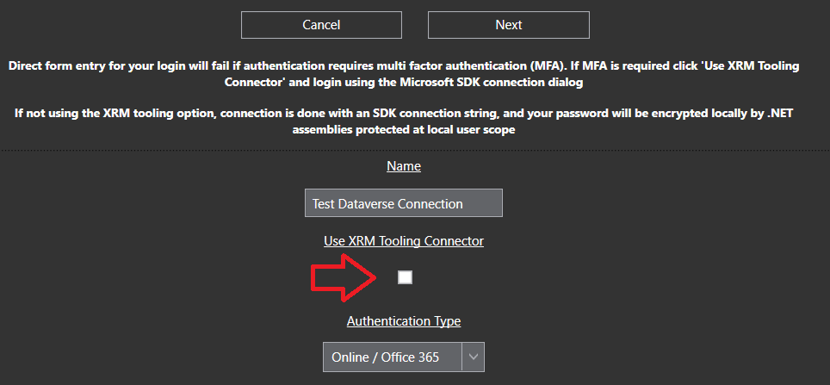

This will popup a login dialog which is part of the Microsoft SDK assemblies. If connecting to a Microsoft online instance you’ll need to click Office 365 and Show Advanced, then enter username and password before hitting Login. This will then progress through the login including any subsequent MFA process which is required

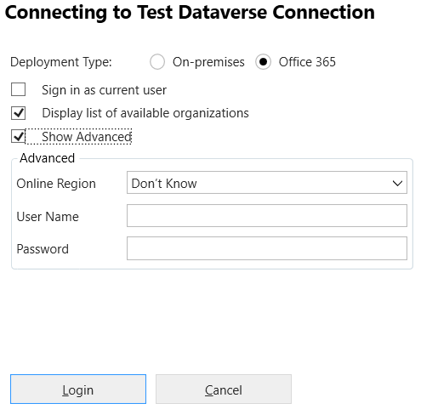

This dialog is managed by Microsoft assemblies using the SDK control documented at the link below  
https://learn.microsoft.com/en-us/power-apps/developer/data-platform/xrm-tooling/use-xrm-tooling-common-login-control-client-applications?WT.mc_id=DX-MVP-5004940

Once the dialog is completed click Next to commit and save to your saved connections

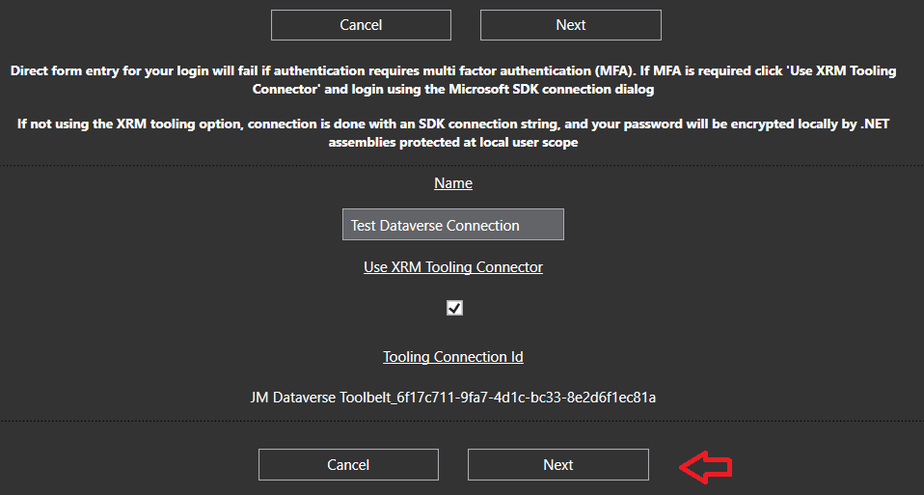This new connection will now become the active connection

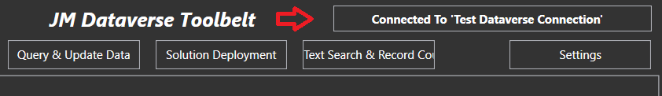

### Create a connection saved and encrypted by the app

To create a connection saved an d encrypted by the app rather than the SDK, skip past the field Use SDK Tolling Connector leaving it unticked

In this case username and password are entered directly into the connection form. Once entered the Org Unique Name field appears for the instance to connect to. If a valid user name and password has been entered, this field displays a dropdown of instances available o the user when the search button is clicked

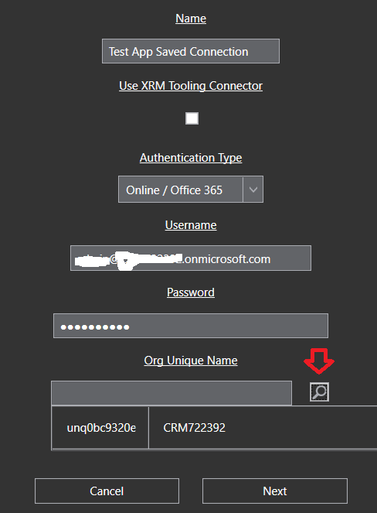

If you need to manually find you organisation unique id see the Microsoft article linked below  
https://learn.microsoft.com/en-us/power-platform/admin/determine-org-id-name?WT.mc_id=DX-MVP-5004940

Once all details are entered including the Org Unique Name click Next to commit and save to your saved connections

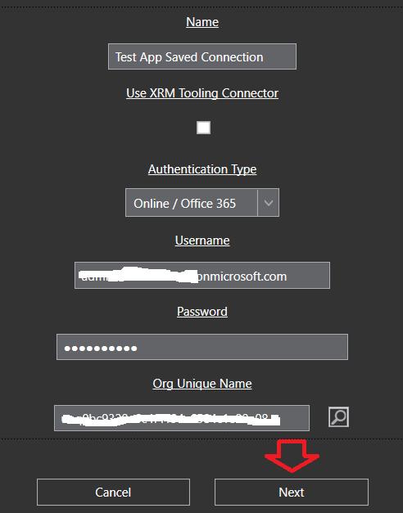

The connection will now become the active connection

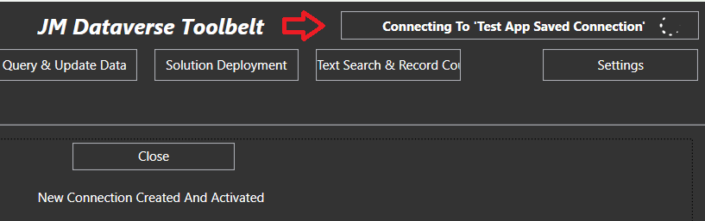

## Manage Saved Connections

To connect using the SDK connector click the button labelled Use XRM Tooling Connector in the connection entry form

Saved connections can be access in the setting menu on the right of the app header

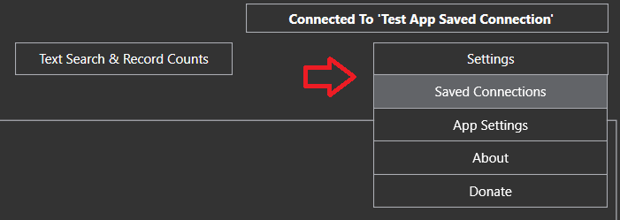

The Saved Connection form can be used to add a connection, open and modify a connections, delete connections, change the active connection, or start a feature dialog for a connection which is not currently active

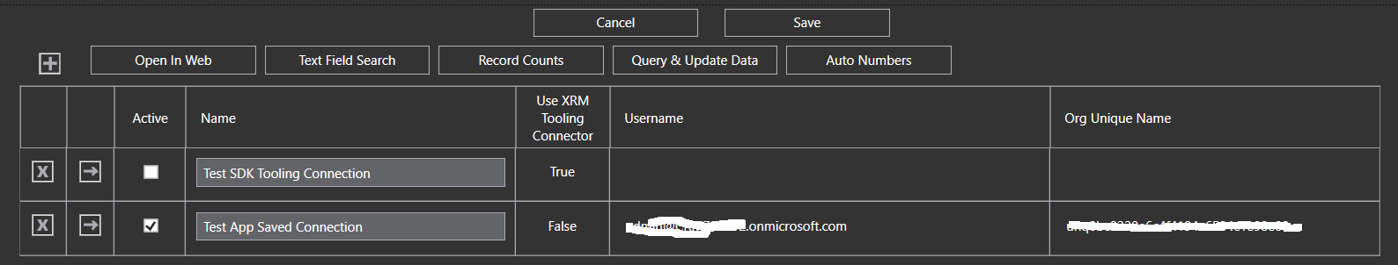

No changes initiated form this form will be committed to your saved connections until the Save button is clicked. This includes any connections add, modify or remove actions on the grid will not be committed until the forms save button is clicked

# App Features

## Query & Update Data

This is the most commonly used feature in this app and can be used to achieve any of the following

* Arbitrarily query data for any record type in the Dataverse instance
* Bulk update columns for the results of a query
* Bulk delete results of a query
* Bulk replace text in string fields for the results of a query
* Copy FetchXml for the query to the clipboard either raw or formatted for JavaScript
* Display total number of records for a query
* Export query results to Excel
* Open result in an editable form containing all columns in the table
* Open results in the Model Driven Web UI

To run a query click the Query & Update button in the main menu. Once loaded select a record type and a query can then be created using a range of conditions, operators and joins

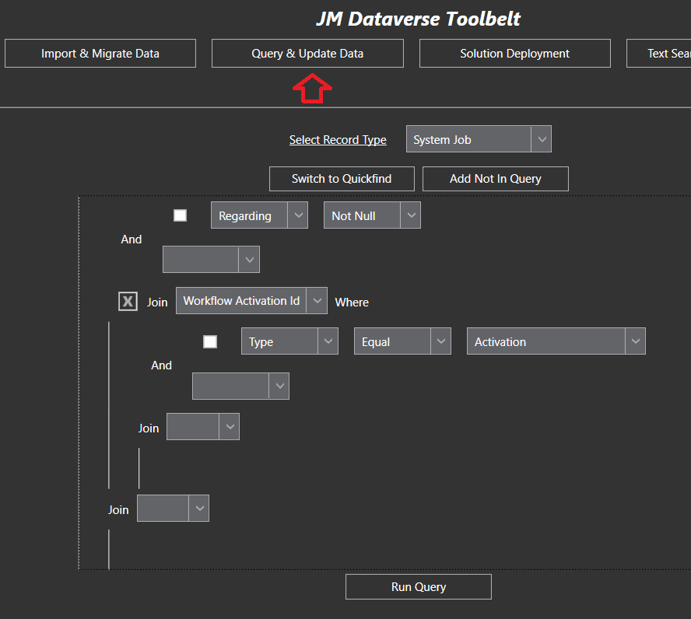

After the Query is run results are displayed in grid form with operations available to perform on the results

In this screenshot I have also clicked Display Totals and the total number of records is displaying in the age count at the bottom of the grid

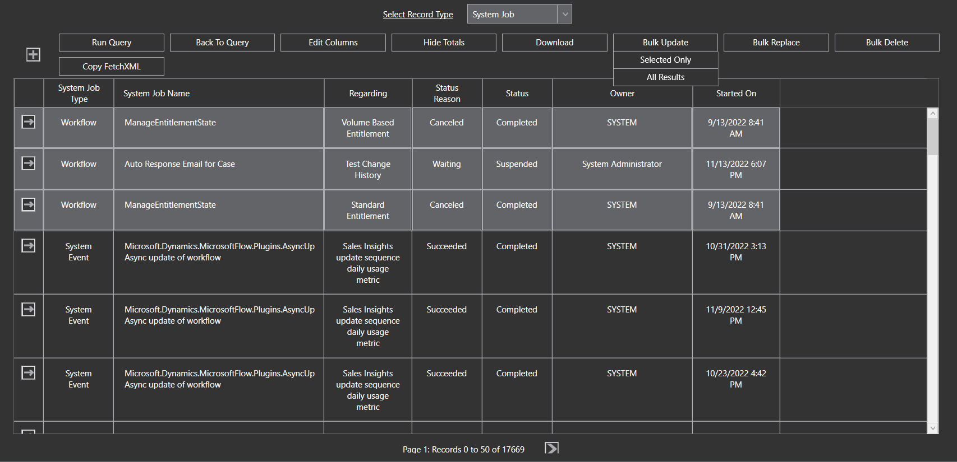

## Customisation Import

This feature allows entity and field metadata to be managed in a spreadsheet and created/updated in bulk

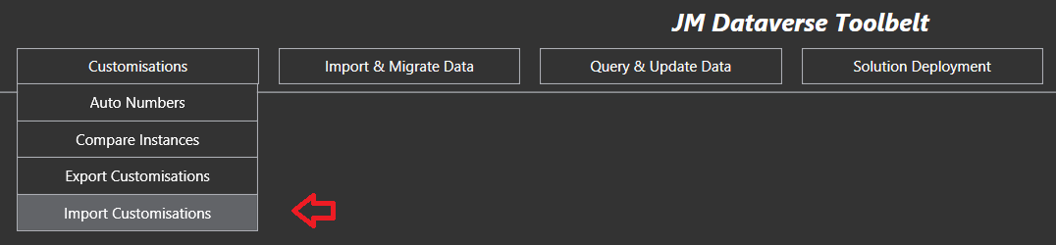

An Excel Template containing the required sheets and sample import data can be downloaded by clicking the “Get Import Template” button on the entry form. This will open an Excel file with similar tabs to the screenshot below

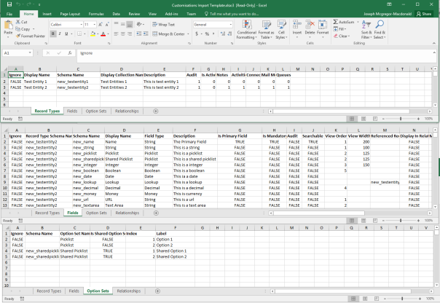

* The Record Types tab contains a row for each entity type to be imported
* The Fields tab contains a row for each field/attribute to be imported*. Note that some of the fields are contextual, for example the “Reference Record Type” column is only relevant for Lookup fields, and the Max Length column is only relevant for text fields
* The Option Sets tab contains picklist option key/labels for either shared or field specific option sets
* The Relationships tab (not shown) contains many to many relationship definitions. I have rarely used this compared to the other import options

*the Fields tab also contains View Order and View Width columns which may be used to set columns in system views for the relevant entity

Once customisations have been defined in the spreadsheet and saved the import may be triggered by entering required details into the form then clicking Import

* Selection of the spreadsheet containing the customisations
* Optionally select to add the components to a solution in the CRM instance (note this does not currently add at the sub-component level. e.g. if there is a field in the case entity included in the import, then all case assets will be added to the solution
* Select which component types in to import. e.g this import may only want to include fields or options sets in the import

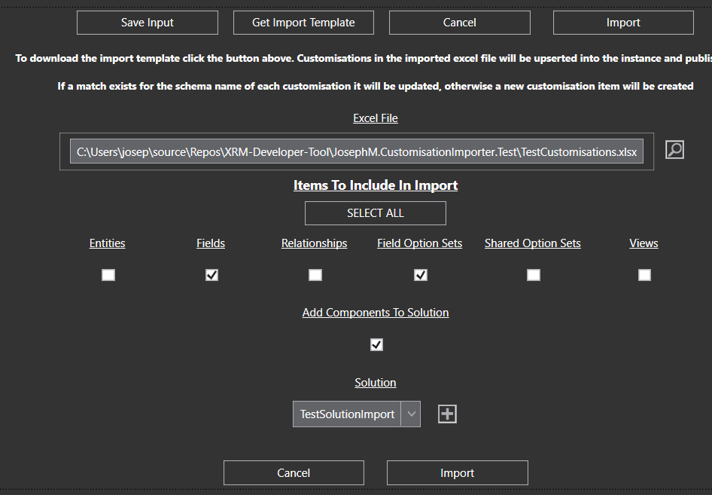

The active connection at the time the entry form was opened will be used for the import. Configuring the connection is detailed in the post [here](https://josephmcmac.wordpress.com/2017/12/20/josephm-dynamics-365-dev-app-configure-connection/)

The import process could take a while depending on the volume and type of cutomisations. Multiple publishes are done as required by the app during the import

If any errors are thrown during the import these will be shown in a grid when completed

This screenshot show the solution in CRM after an import of the Excel template unchanged. As shown the various entities and shared option set have been added into the solution

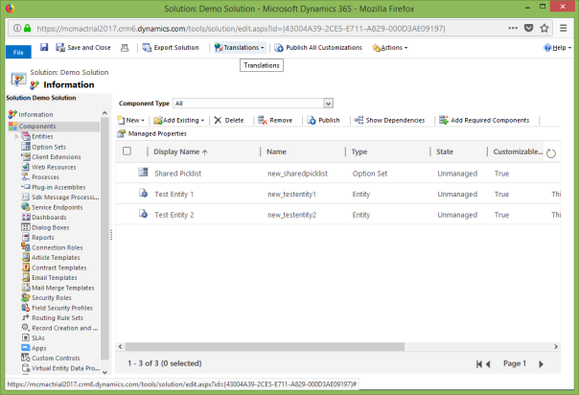

Be aware this feature is also available as part of my Visual Studio extension (detailed [here](https://josephmcmac.wordpress.com/2017/12/20/dynamics-365-visual-studio-extention-josephm-xrm-vsix/))

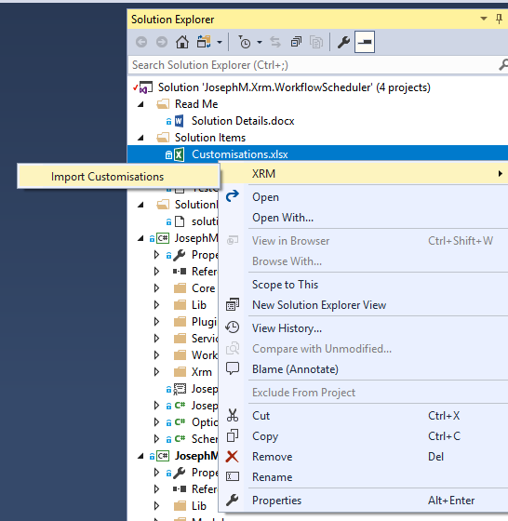

## Migrate Records

This feature provides a simple way to select a source and target instance, then one or more sets of table data to move from the source into the target

[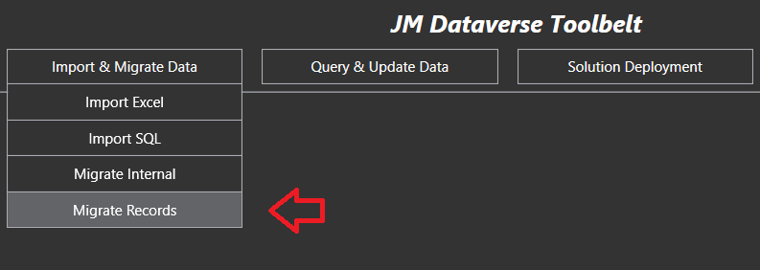](https://josephmcmac.files.wordpress.com/2022/11/image-30.png)

[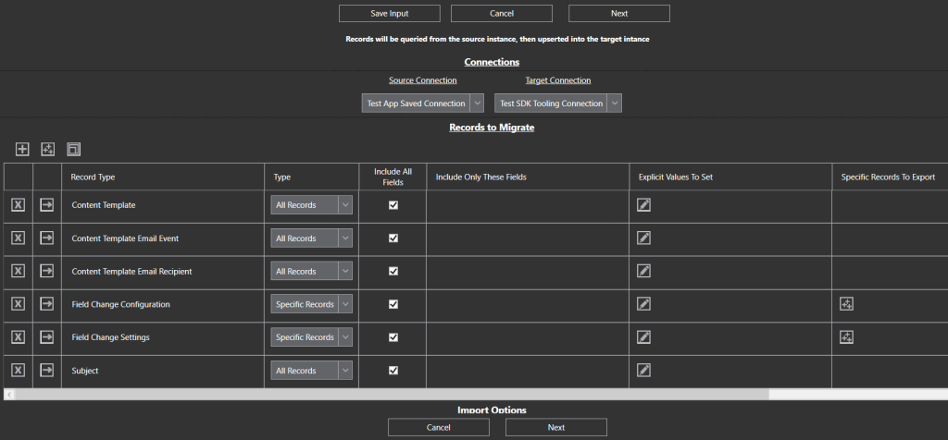](https://josephmcmac.files.wordpress.com/2022/11/image-31.png)

The process will both create new records, as well as update existing records when matches are found in the target instance

## Solution Transfer

This feature provides a quick way to move a solution from a source to target instance

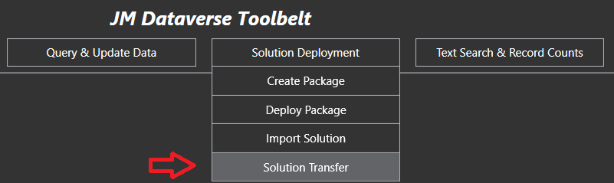

Options are provided for the solution being transferred including

* Updating solution version for the transfer
* exporting as managed
* overwrite customisations
* install as upgrade (if newer managed version)

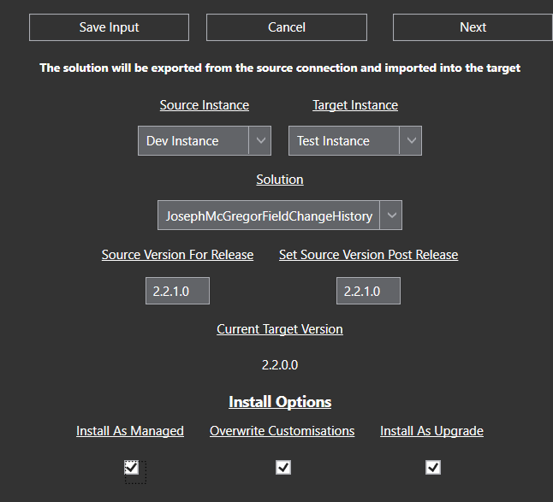

When Next is clicked to commence the Transfer regular updates during the transfer informing of progress



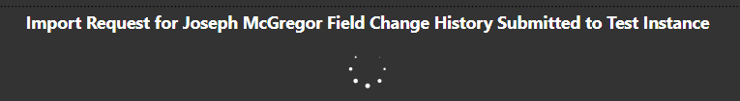

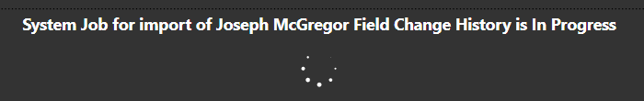

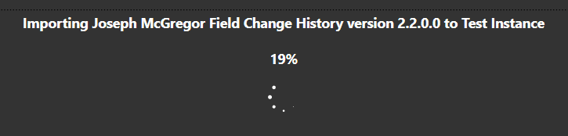

Particularly if regular deployment are being made this, this feature provides a very quick and simple way to get solutions deployed across environments

## Text Field Search

The Text Field Search feature in Dataverse Toolbelt enables searching for one or more specific text strings within the string fields of some or all record types in the system

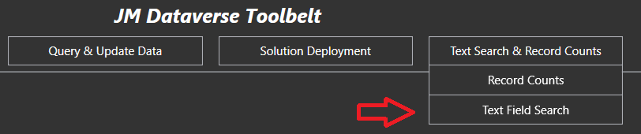

Various search options are provided including

* and / or searches for multiple search terms
* limiting specific tables searched by either inclusion or exclusion
* excluding specific fields form the search
* stripping html tags from searched content

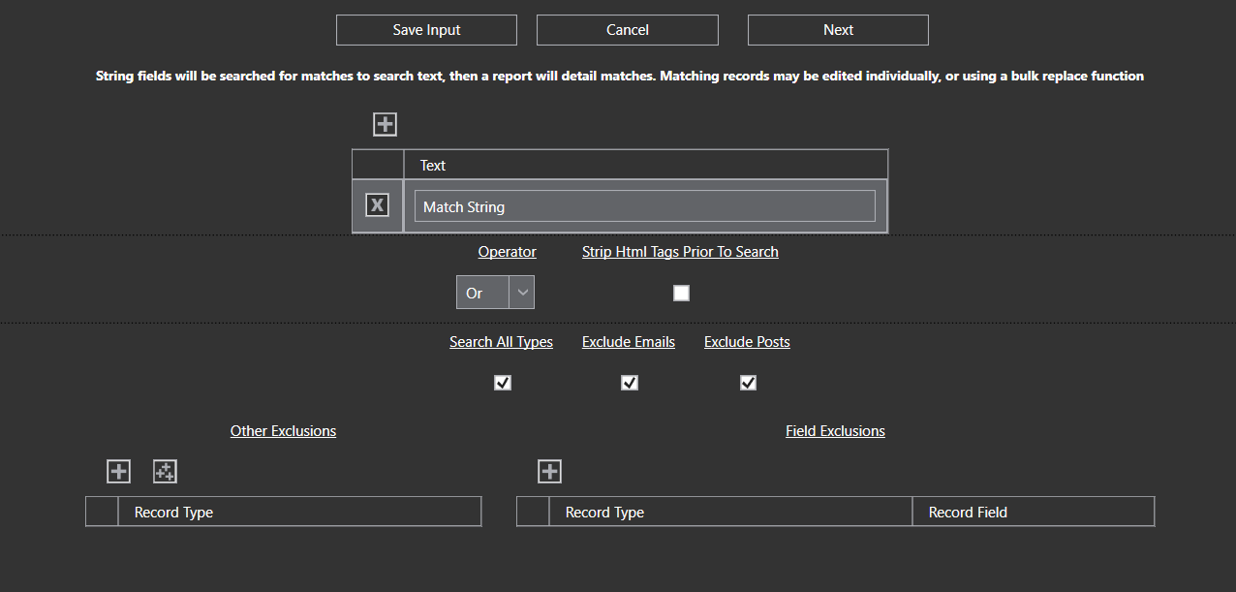

Depending on the search configuration, the number of tables, and the volume of data, the search could take some time. The app provides progress bars as it searches through the system to give indication of progress

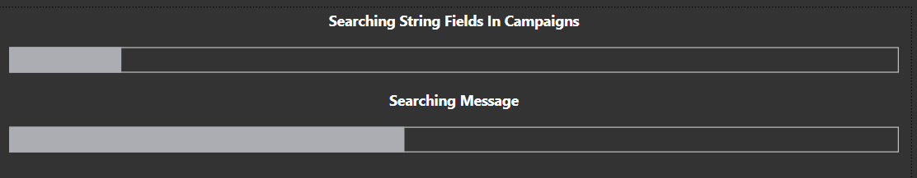

Once completed a report of table and field matches is displayed in a grid, and can be exported into Excel

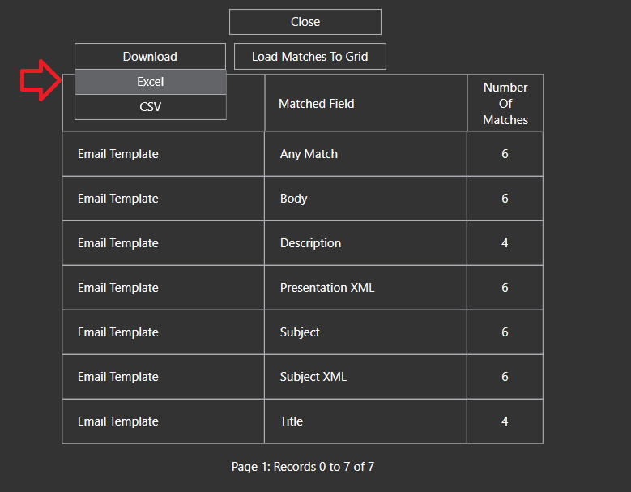

Results can be loaded to a grid and inspected, and if required a bulk replace process run

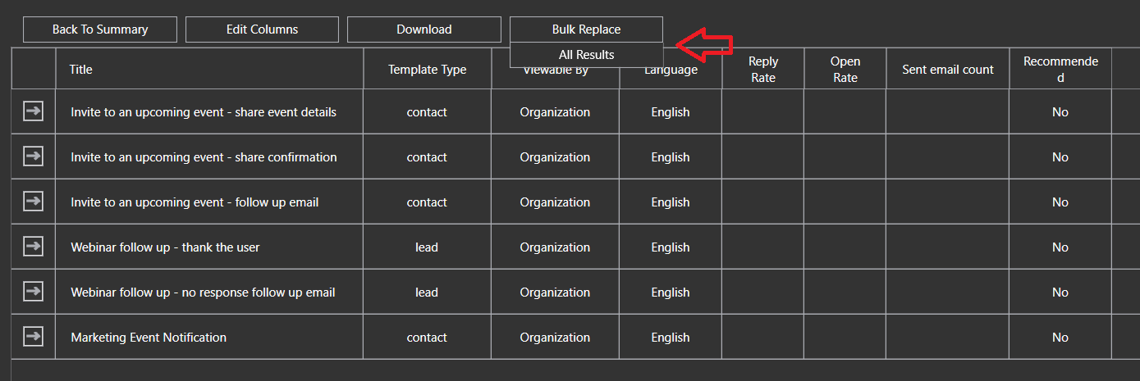

The bulk replace process enables replacing one or more text strings, in one or more fields within the matches results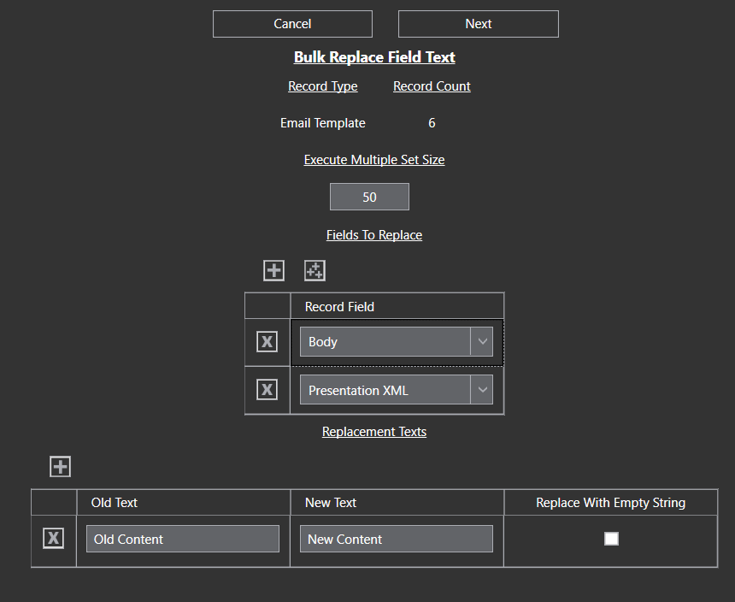

## Configure Autonumber

The Autonumber feature in Dataverse Toolbelt assists with configuring the platforms native autonumbering feature and supports

1. configuring string columns with new autonumber configurations
2. modifying the configuration of existing autonumber columns
3. updating the seed (current position) of an autonumber column

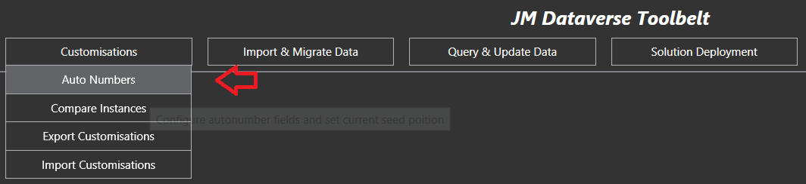

To view and configure autonumbers for a specific table, search and select the desired table from the autocomplete dropdown

c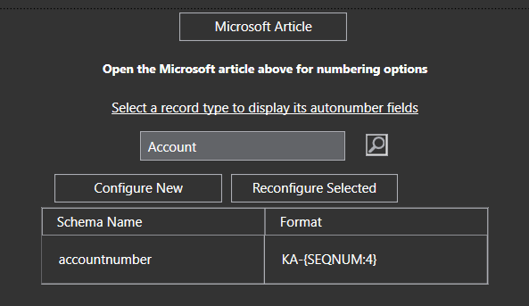

TO configure a new column as an autonumber select Configure New, otherwise to update an existing column click Reconfigure Selected

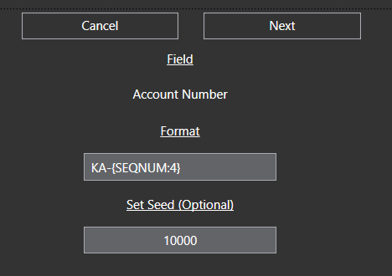

See Microsoft documentation linked below for Autonumbering options  
<https://learn.microsoft.com/en-us/dynamics365/customerengagement/on-premises/developer/create-auto-number-attributes?WT.mc_id=DX-MVP-5004940&view=op-9-1#autonumberformat-options>

## Customisation Export

The customisation export feature provides option to export a range of system information into an Excel spreadsheet including

* Table, column & option set metadata
* Installed solutions
* Configured workflows
* Plugin types and SDK message processing steps
* Security roles, user, and team information

The feature is mostly used for exporting column and option information into Excel so it can be search & filtered for specific information, documented, or sent as required to end users

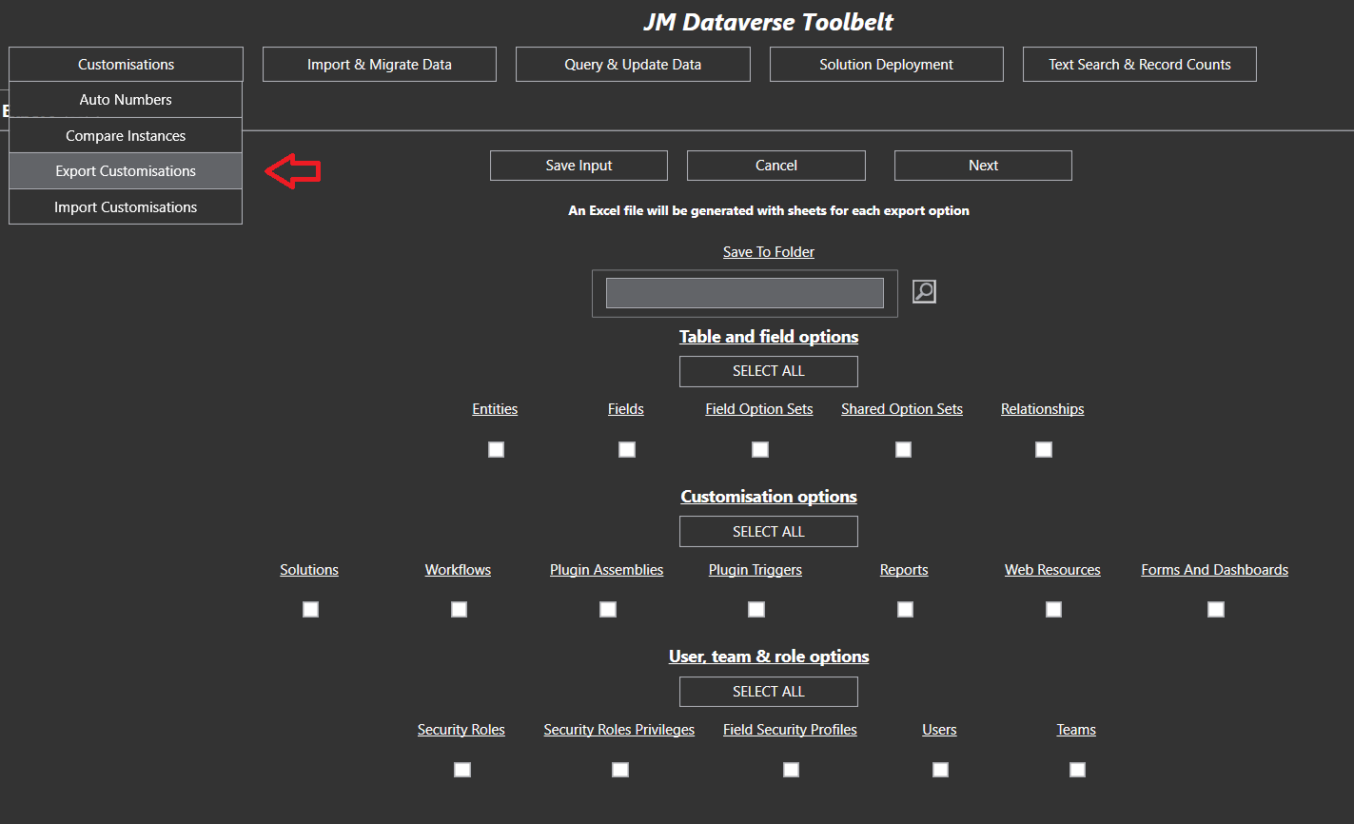

The output of this process is an Excel file with sheet for each type of information included in the export

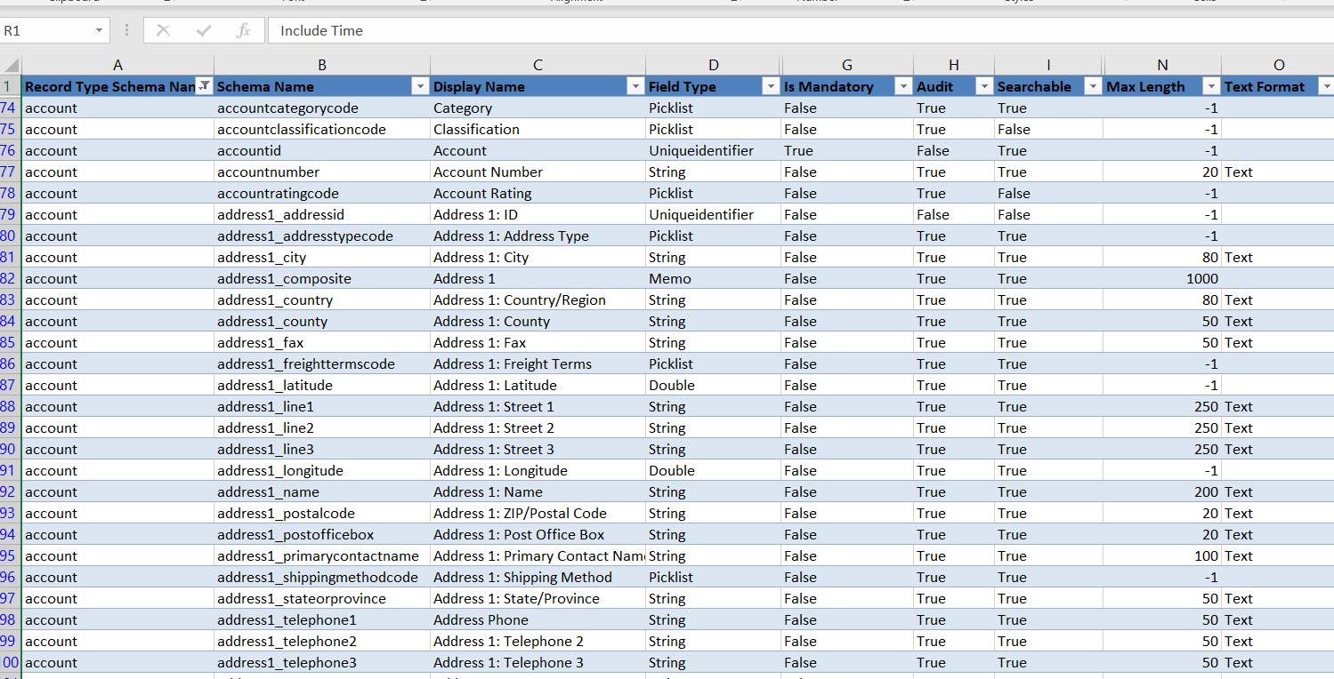

## Excel Import

This Excel import feature provides a means to import data from an Eccel file into D365 table data

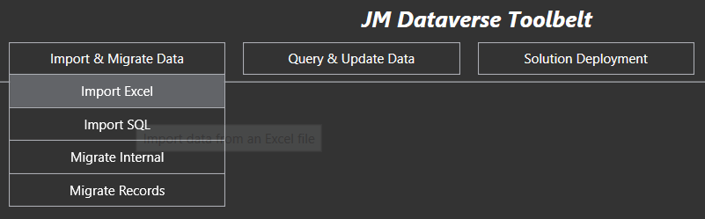

With an Excel file selected, each tab can be mapped to a target record type

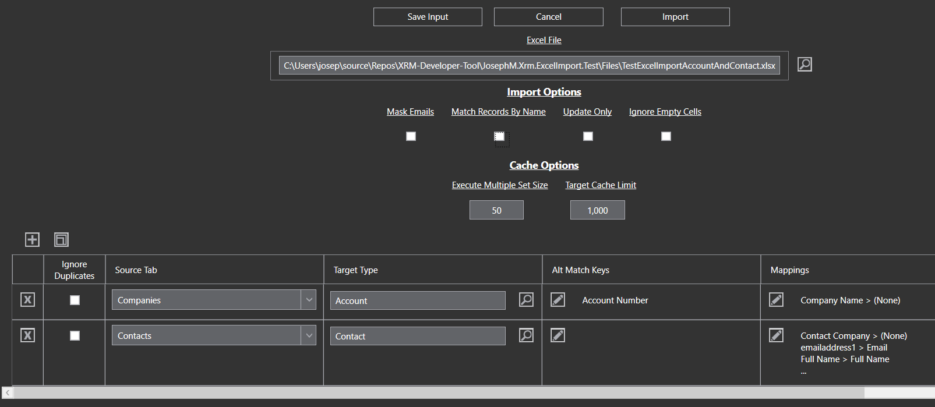

And within each table map, source columns in the spreadsheet can be mapped to target columns in the table

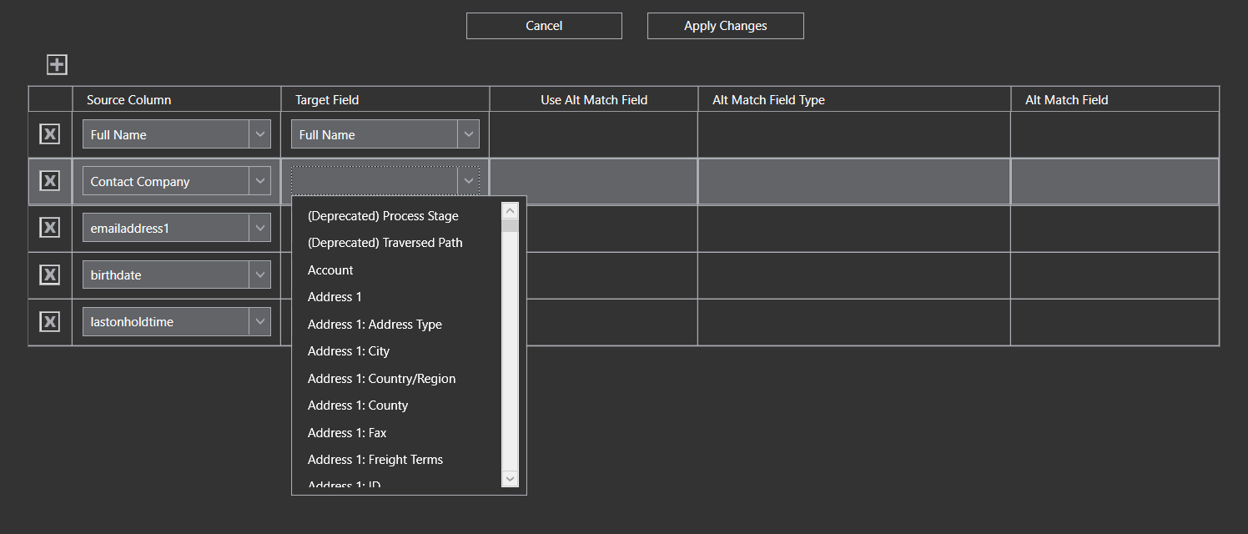

The feature provides several options for matching target records, as well as matching lookup columns on alternative target fields

## Instance Comparison

This feature compares components and records between 2 instances and provides a report where it has identified differences

[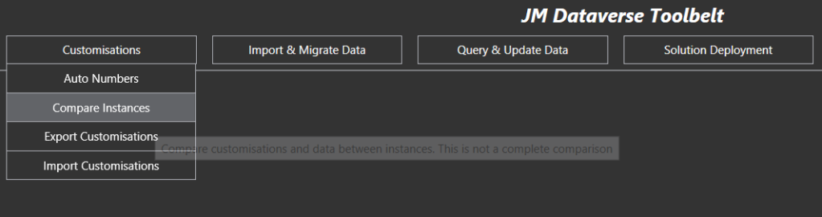](https://josephmcmac.files.wordpress.com/2022/11/image-53.png)

Cases where I have found value in this feature include

1. Workflows and business rules not kept consistent between production and non-production environments. The feature identifies different activation states, different rules within the process, or where the customisation exists in one instance but not in the other
2. Identifying differences in reference and configuration data between production and non-production environments
3. Identifying components changed during a release cycle, but not included in a release package
4. General checks of consistency between production and non-production environment

Note this feature does not compare every customisationtype. It only covers those I have implemented it for. Refreshing non-production instances from production is often a better option where instances have becomes too far divergent

The screenshot below shows option selected for a comparison. Note Web Resource takes the most time and volume of data to compare so ensure to exclude it where not required

[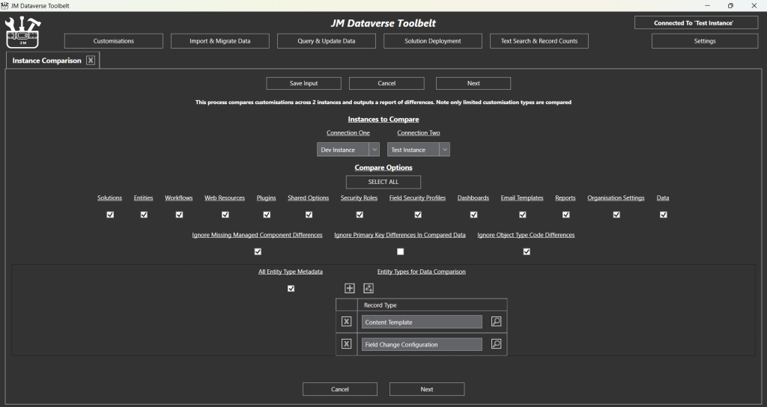](https://josephmcmac.files.wordpress.com/2022/11/image-54.png)

Example output summary of the process is shown below (for completely different instances)

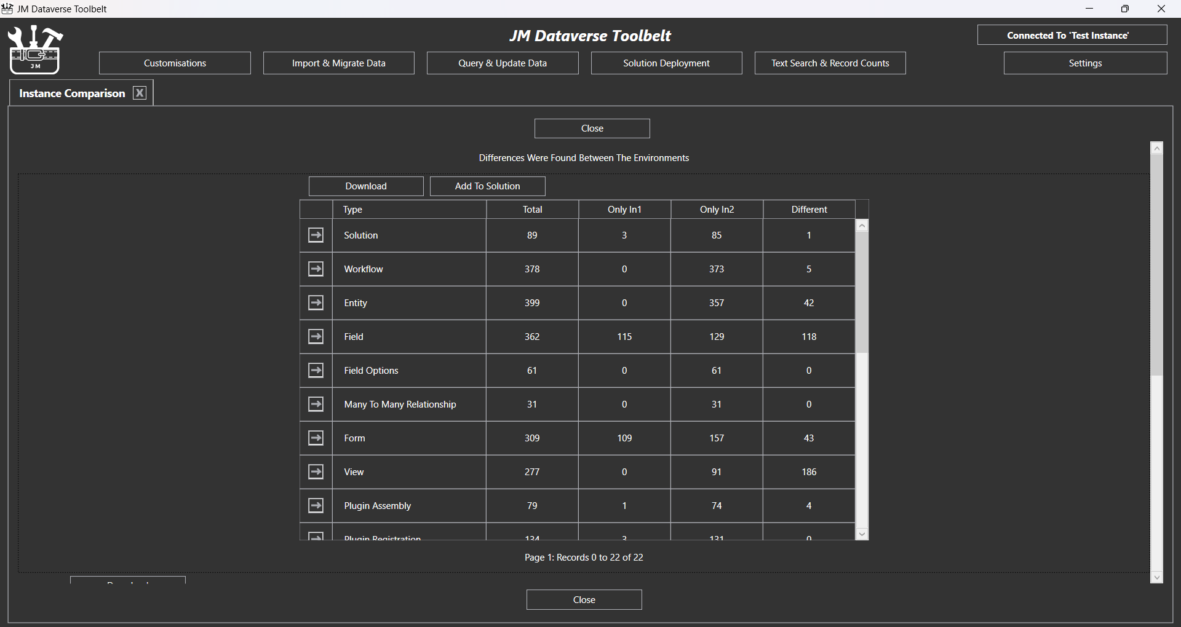

With details of each specific further down the form. This detailed report can be exported to Excel for further inspection of specific differences

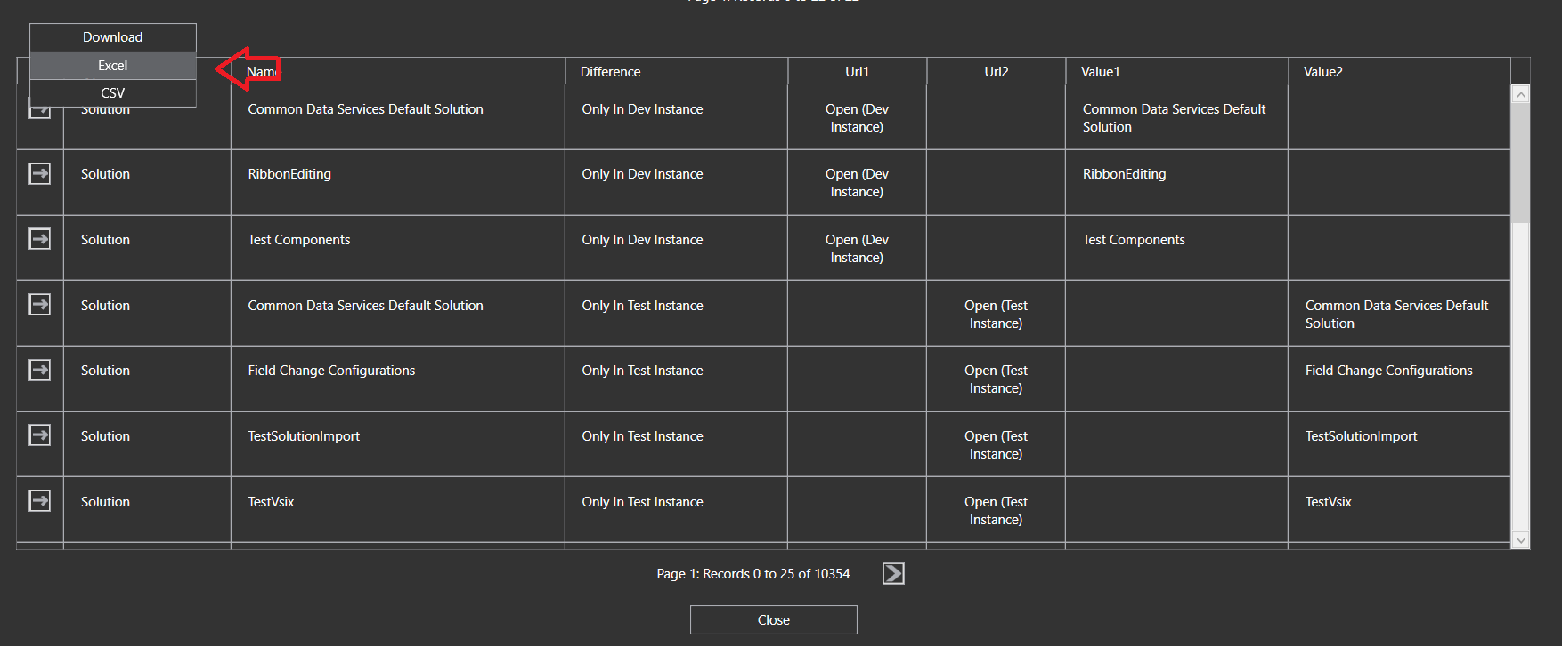

## Record Counts

Record Counts is a simple feature in the Dataverse Toolbelt to get total record counts from an instance

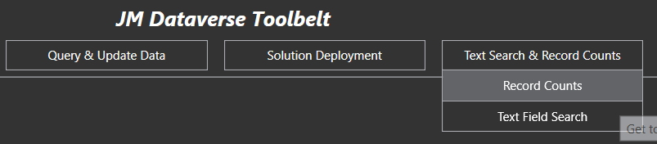

Options for the output include

* Counts may be generated for all, or only selected record types
* Counts may be grouped by record owner
* Counts may be filtered for those only owned by a specific user

The Screenshot below show an example result for all record types which can be export to Excel where required

